# EN3160 Assignment 1- I.P.D.D.Rajapaksha 210503H

GitHub : <https://github.com/DinethraDivanjana2001/EN3166-Image-processing-and-machine-vision/tree/main>

## 1.0. Intensity transformation

Transformation function

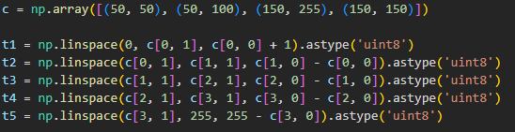g

=

## 2.0. Brain image white and grey matter separation and intensity transformation

Here I got the two points in the brain image as reference and located one in the white matter area and the second one in the grey matter area then took an intensity range for both of them as 7 % and using that range separated the two areas. Then, I did the intensity transformation.

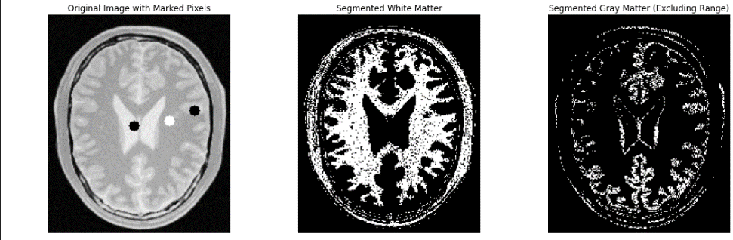But middle part should not include to any of those area so remove that part by getting another intensity value from middle point but it reduce the accuracy of the grey matter area.

Then

define the intensity transformation function as below and get the output sing previous method.

## 3.0. Gamma Correction and Histogram Analysis

a).

b).

## 

First applied gamma correction to the luminance (L) channel of an image converted to the Lab* color space. Then used two gamma values, γ=0.5 and γ=2.2, to enhance brightness and contrast. The process began by converting the image from BGR to Lab* color space. After separating the L, a, and b channels, applied gamma correction to the L channel using both values. Once the correction was complete, merged the adjusted L channel with the original a and b channels. Finally, converted the combined result back to BGR format for display.

## 4.0. Increasing the vibrance of a photograph

a). convert it to HSV color space, extract and display the Hue, Saturation, and Value channels

b). apply intensity transformation to channel

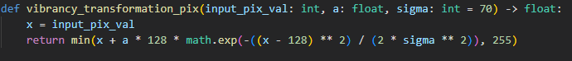

c).adjust a value and check what is the best by comparing the images with the original one.

Clearly see when a=0.2 is the best option

Then recombined frame image used to get the vibrance-enhanced image, and the intensity transformation

## A close-up of a graph Description automatically generatedA computer screen shot of text Description automatically generated5.0. histograms before and after equalization.

After equalization image becomes brighter and can clearly see in the graph pixel intensity increase as expected.

## 6.0.

a).Load Image and Split into hue, saturate and value Planes

b).Next Create Foreground Mask



c).Then extract foreground

b) c)

d).compute the histogram the botain cumulative sum

e). histogram-equalize the foreground.

f). part this code line for combining foreground with background

histogram equalization to the RGB channels independently. This approach led to color distortions, as it did not take into account the interrelationships between the channels. The resulting image appeared grayish, indicating that the histogram equalization process faced issues.

Next, I included the original black background in the histogram calculation, which skewed the results and negatively affected the overall outcome. As a result, the image became bright and washed out, suggesting that many pixel values were pushed toward the higher end of the intensity range.

Ultimately, this method caused a loss of color saturation, further compromising the quality of the final image.

## 7.0. Spatial filtering

a).uses the built-in filter2D function to apply the Sobel filter.

b). shows a custom Sobel filter implementation.

c).applies separable Sobel filters to break the filtering into vertical and horizontal components.

## 8.0. Zoom function

In the first case, when zooming a small image, the SSD values are higher (4231.96 for nearest-neighbor and 4166.14 for bilinear), indicating significant differences from the original large image. The nearest-neighbor method produces more pixelation, while bilinear interpolation smooths the zoomed image. In the second case, with a very small image, the SSD values are lower (3116.37 for nearest-neighbor and 2989.72 for bilinear), reflecting less variation due to the lower detail in the very small image. Overall, bilinear interpolation provides smoother results, but both methods struggle to restore lost detail.

## A close-up of a flower Description automatically generatedA yellow flower with a black background Description automatically generatedA computer screen shot of text Description automatically generated9.0. Image Segmentation and Enhancement Using grabCut Algorithm



When the background is blurred using a Gaussian blur, the kernel (filter) considers nearby pixels to compute the new value for each pixel. If there are dark pixels in close proximity to the edge of the flower, the blur effect will incorporate these dark pixels into the neighboring areas, causing the area just beyond the flower to appear darker. This is a side effect of how Gaussian blur works—it smooths the transition by averaging pixel values, so if some dark pixels are near the bright edge of the flower, the blur causes a darker halo-like effect near the boundary.